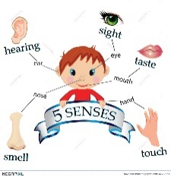
WANTED
Scientists
For
Little Scholars Academy’s 5 Senses Summer Camp

When: June 17- 20, 2024
Where: Little Scholars Academy
Time: 9:00 a.m. – 12:00 p.m.
Who: Children aged 3-5 years old
Contact Number: 770-920-9059
Cost: $80.00 per child
--------------------------------------------------------
Please cut off this portion and return it to the preschool to register your child. Keep the top portion for your refrigerator.
Child’s Name: ______________________________________ Age: __________
Parents’ Name: _____________________________________________________
Parent Contact Information: ___________________________________________
Allergies: ___________________________________________________________
If paying online, please put “For Summer Camp” in the notes box.
If paying by check, please make check payable to Douglasville FUMC.
**Children must be potty trained. Thank you for your understanding**

